ONEWAY SA BY Temp
/STATISTICS DESCRIPTIVES HOMOGENEITY WELCH
/PLOT MEANS
/MISSING ANALYSIS.

Oneway

Notes
Output Created |  | 05-May-2019 23:53:28
Comments
Input | Active Dataset | DataSet0
Input | Filter | <none>
Input | Weight | <none>
Input | Split File | <none>
Input | N of Rows in Working Data File | 30
Missing Value Handling | Definition of Missing | User-defined missing values are treated as missing.
Missing Value Handling | Cases Used | Statistics for each analysis are based on cases with no missing data for any variable in the analysis.
Syntax |  | ONEWAY SA BY Temp  /STATISTICS DESCRIPTIVES HOMOGENEITY WELCH  /PLOT MEANS  /MISSING ANALYSIS.
Resources | Processor Time | 00 00:00:00.156
Resources | Elapsed Time | 00 00:00:00.170

[DataSet0]

Descriptives
SA
 | N | Mean | Std. Deviation | Std. Error
Between 22°C-18°C | 9 | 24.2222 | 10.58038 | 3.52679
Between 24°C-26°C | 6 | 32.3333 | 26.32616 | 10.74761
In between 24°C and 22°C | 13 | 27.5385 | 15.88299 | 4.40515
Less than 18°C | 2 | 14.0000 | 12.72792 | 9.00000
Total | 30 | 26.6000 | 16.74062 | 3.05640

Descriptives
SA
 | 95% Confidence Interval for Mean |  | Minimum | Maximum
 | Lower Bound | Upper Bound | Minimum | Maximum
Between 22°C-18°C | 16.0894 | 32.3550 | 15.00 | 50.00
Between 24°C-26°C | 4.7057 | 59.9609 | 6.00 | 67.00
In between 24°C and 22°C | 17.9405 | 37.1365 | 14.00 | 62.00
Less than 18°C | -100.3558 | 128.3558 | 5.00 | 23.00
Total | 20.3490 | 32.8510 | 5.00 | 67.00

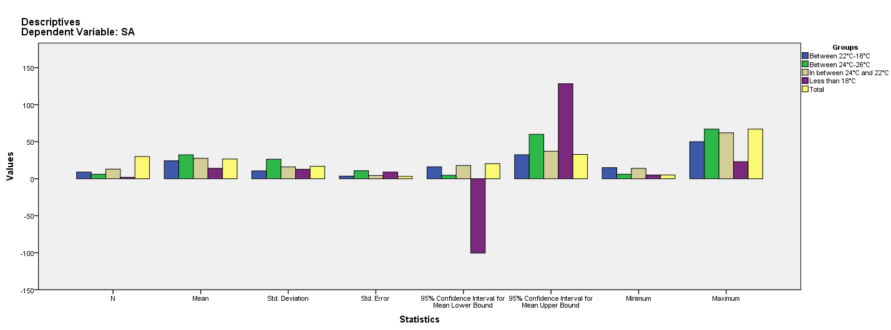

Test of Homogeneity of Variances
SA
Levene Statistic | df1 | df2 | Sig.
3.292 | 3 | 26 | .036

ANOVA
SA
 | Sum of Squares | df | Mean Square | F | Sig.
Between Groups | 577.080 | 3 | 192.360 | .662 | .583
Within Groups | 7550.120 | 26 | 290.389
Total | 8127.200 | 29

Robust Tests of Equality of Means
SA
 | Statisticª | df1 | df2 | Sig.
Welch | .605 | 3 | 4.596 | .642
a. Asymptotically F distributed.

Means Plots

